附件4

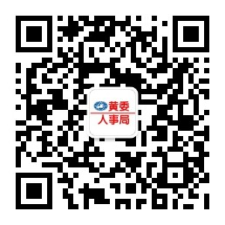
“黄委人事局”微信公众号二维码

